Development of Program roadmap
Project PROPOSAL
Yuanxin Huang Jialao Liu Yilin Peng
  - March 18, 2026

Executive Summary
This assignment aims at developing a Program Roadmap system for Adelaide University. The aim of this task is to create a website prototype which can provide existing and potential students with program information clearly and logically.
Currently, the data on curricula, program options, companies and alumni are scattered in multiple webpages and reports, which do not allow an easy access by students seeking them. Therefore, students frequently spend hours searching for information about courses, electives, and jobs; our Program Roadmap Website will consolidate that information into one place making the data more accessible.
The suggested system shall be based on the two layered platform, where the first layer aims at supporting existing students, including a well-ordered access channel to the program’s information, learning process guidance, industrial opportunities, and alumnus links. Level two is used as a marketing and interaction channel to prospective students, offering transparent pathways through the courses and into careers.
This work would have a number of outputs such as users requirements, information architecture, wireframe prototypes, conceptual data models, and an implementation roadmap which can be used for the future development.
The estimated project budget is AUD $18,535 which mainly represents the team labour and supporting project resources. Project will be complete in 10 weeks time, generating a range of outputs in a defined format to provide the basis for further work on deploying this kind of system at Adelaide University.

Project Background and Description

The Adelaide University faces a complicated higher education sector, wherein the students as well as potential applicants are expecting to get timely, clearly, and structured electronic data. Today, Universities are not only competing with their academic prestige; they also distinguish themselves by how clear and transparent their communication is, by the quality of their online experience, and how they can show what is being accomplished with these programs.
Today's education and career information is often scattered among multiple online resources, brochures, and documentation. This fragmentation for existing students raises the barrier of entry in finding important information about how the programs are organized, curriculum design (e.g., electives), curriculum mapping, and industry connection; and challenges related to linking up with internships for a significant portion of the student body: career pathways, and appropriate student supports. The problem faced by potential students is to obtain an attractive and easily understandable description of what the university has on offer, graduate outcomes, and longer term benefits of enrolment.
The Program Roadmap tool seeks to address all the above issues through implementation of an organized online resource in two tiers: the first tier is designed to guide prospective and enrolled students to resources about programs and graduates. Whereas the second one serves more of an advertising function to future students. With all these fragmented sources of information brought together in one place (roadmap), it becomes much easier for the organisation to guide its employees as well as customers on how they should proceed along their journey.
Four main goals of the project are as follows:
- To identify and analyze the information needs of both current students and prospective students.
- To define a two-level website structure. This will keep student support and marketing separate but linked.
- To design a logical information architecture and content organization model for roadmap style navigation
- To produce a set of practical and implementation-ready deliverables that Adelaide University can use as a basis for future development.
This proposal will serve as a useful tool in terms of facilitating access to, and easier searching for, program data because it would provide an overall map: the system concentrates what has been scattered data so that one can send customized messages according to needs of existing or potential clients. This connected online experience will bring to higher engagement and better student satisfaction and therefore marketing of the University. It has enabled them to provide a strong strategic basis for the project as well as a suite of formalized design artefacts that can be used to scale up this way of working across the entire University.

Project Scope
This project is basically analyzing, designing and planning an online program roadmap web site of Adelaide University. The project will outline what do this website needs to do; who does it serve; how will it inform solidifying development implementation and other outputs moving forward into implementation. The project will not result in a complete end-to-end university system ready for deployment at this date. Instead that it will output an explicit grounded concept along with the design/planning artefacts.

Inclusions
The following aspects of the project are considered within scope:
- Analysis of the needs of current students and prospective students in relation to program, study, industry, and alumni information.
- Consultation with stakeholders to identify and analyze their main needs and wants as reflected in documents.
- Definition of the two-level platform concept, including the distinction between student-support functions and prospective-student marketing functions.
- Development of the platform’s information architecture, user journeys, and content taxonomy to support structured and maintainable roadmap-style navigation.
- Create wireframes or a basic prototype, focusing on the most important user pathways.
- Set up a conceptual data model to handle things like roadmap information, program details, industry links, and alumni profiles.
- Definition of relevant functional and non-functional requirements, including usability, maintainability, and future scalability.
- Preparation of an implementation roadmap outlining how the proposed solution could be developed in a later stage.
- Development of project evaluation criteria from the client’s perspective.

Exclusions
Specifically excluded from the scope of this effort is::
- Full production deployment of a live university platform.
- Integration with internal Adelaide University enterprise systems unless specifically approved and supported by the client.
- Ongoing content maintenance and operational ownership after project completion.
- Development of a native mobile application.
- Complete software engineering implementation of every feature on the platform.
- Advanced analytics or recommendation engines.
- Transferring all current university content to the suggested platform..

Risks
Considering this project is for developing a web-based application within a strict 10 week’s time frames, risks identified in this project will be more relevant to time constraints, technological risks, and team management. Since this project is based on conceptual design and development of prototypes, risks associated with system deployment will not be considered in this project. Communication is key for the success of this project.

Internal Risk
Risk | Probability (out of 1.0) | Impact | Mitigation Strategy
Project data loss | 0.1 | Loss of significant project progress, causing delayed submission | Use GitHub for version control and maintain local backups on each member's device
Team member unavailability | 0.1 | Assigned tasks left unfinished, affecting overall completion | Share progress updates regularly in group chat so others can take over tasks temporarily if needed
Technical challenges and failure | 0.3 | Additional time needed to resolve difficulties, potentially reducing deliverable quality | Collect technical issues and discuss with peers and mentors at weekly meetings
Time limitation | 0.2 | Increased pressure on team, potentially reducing project scope | Follow the Gantt Chart schedule and reprioritize tasks early if delays occur
Ineffective communication | 0.3 | Misalignment in understanding project requirements among team members or with the supervisor | Maintain detailed meeting minutes after every meeting and share with all stakeholders for confirmation
Data breach | 0.1 | Exposure of student data or api key data, leading to privacy concerns | Use only sample or anonymized data in the prototype; avoid storing real personal data

External Risk
Risk | Probability (out of 1.0) | Impact | Mitigation Strategy
Conflicting expectations between current and prospective students | 0.2 | Design fails to serve both audiences, requiring rework | Define clear user personas early; validate Level 1/Level 2 designs separately
Delayed or insufficient feedback | 0.3 | Approval delays compress later project phases | Request timely feedback from clients and stakeholders
Incomplete or outdated program information | 0.4 | Inaccurate content reduces platform credibility | Cross-reference both university sources; confirm with program administrators
Users find navigation structure confusing | 0.3 | Low adoption and negative usability feedback | Conduct early usability testing with wireframes and iterate before development
Scope creep from roadmap into full student portal | 0.2 | Exceeds timeline and budget, reduces quality | Document change requests and assess impact before accepting any ad

Budget
Budget Item | Estimated Cost | Justification
Project labour | $16200 | Covers estimated team effort across project management, stakeholder analysis, information architecture, prototype design, documentation, and quality review over the 12-week project period.
Software and design tools | $300 | Allowance for optional software subscriptions or premium design/collaboration tools if required.
Technical resources and support | $150 | Small allowance for hosting or technical resources to support prototype demonstration
Communication and meeting costs | $100 | Covers incidental communication, online meeting support, and possible documentation or transcription-related costs.
Testing support | $100 | Allowance for basic usability review activities or participant support if informal testing is conducted.
Contingency | $1685 | To cover unexpected costs
 | $18535
Contingency: Approximately 10% of total estimated cost to cover unexpected risks and uncertainties.
$16200 = 3People * 15Hours * 12 weeks * 30AUD

Roles and Responsibilities

The project team would be divided by task, along the lines of the major work streams needed to create a quality proposal and related products. Task assignment was considered with in mind that all members of the group could own one major piece of the project but also support each other's peer review and integration activities as part of the entire project, so there would not be a sense of separate work silos where only one person was accountable.

Team Member 1: Yilin Peng - Project Manager & Front-end developer
Responsibilities:
- Quality Control: Controlling the project process in terms of scope, budget and timeline to ensure that final deliverables are as per desired outcome for the project.
- Project Management: Organizing and conducting a weekly meeting of all project participants and maintaining communications among the parties involved in the project, reporting regularly on progress to our customer.
- Front-end development: Assisting to design and develop the web app based on Vue framework and related skills (HTML/CSS/ JavaScript), cooperating with the other members for providing easy use of users.
Team Member 2: Yuanxin Huang - Business Analyst & Quality Assurance Lead
Responsibilities:
- Requirement Analysis: Analyse user needs for both current and prospective students.
- Stakeholder Analysis: Identify key stakeholders and their expectations.
- Risk & Data Management: Identify project risks and develop mitigation strategies. Implementing version control via GitHub to maintain data integrity.
- Documentation Support: Contribute to key proposal sections and ensure consistency.

Team Member 3: Jialao Liu - Information Architecture & Development Lead
Responsibilities:
- Design and Prototyping: Producing low-to-high fidelity wireframe prototypes, a site map, and a content hierarchy.
- Full-Stack Implementation: Led the development of code for front-end vue3, Node.js and MySQL back-end database..
- Automation: Developing Selenium scripts for UI automation to verify cross device and different browser compatibility.
- GitHub Maintenance: Keeping the repo clean by eliminating redundant codes and completing the README guide to be implemented.
Shared Responsibilities
Everyone in a project will be responsible for identifying risks, controlling costs and ensuring that high standards are maintained throughout. The end-stage checking is done jointly by everyone which means there should be less silo working:ensuring that the quality of the various products is high; providing consistent message to stakeholders, when presenting and seeking their approval.

Communications Plan

The communication plan is designed to ensure clear, timely, and effective information exchange among all stakeholders.
Communication Activity | Purpose | Frequency | Method
Client Progress meeting | Clarify project requirements, confirm deliverables, and obtain feedback | When required | In-person
Internal team meeting | Discuss tasks | Weekly | In-person
Informal team coordination | Quick coordination | Daily | WeChat
Document review and approval | Ensure project documents and deliverables are reviewed and agreed upon by all members | At key milestones | Shared documents
Academic mentor meeting | Review project progress, discuss challenges, and receive academic guidance | Weekly | In-person/Teams

Project Stakeholders

Name | Role | Interest in the project
Adelaide University client representative | Acts as the primary client and project owner; defines project requirements and approves deliverables | Ensures the platform aligns with the university's strategic goals and meets institutional standards
Current students | Primary end users | Use the platform to access structured program information and career pathways.
Prospective students | Target audience | Access accurate and up-to-date information about their program, study pathways, industry connections and alumni networks
Program administrators | Provide and maintain program-related content on the platform | Ensure program information is accurately represented and regularly updated to reflect current offerings
Student support | Contribute relevant support resources and services featured on the platform | Ensure students are aware of and can easily access available support services through the platform
Marketing and recruitment staff | Oversee the platform's marketing functionality, including the design and placement of promotional content and interactive quiz feature to guide prospective students in selecting suitable study programs. | Ensure the platform effectively attracts and engages prospective students through interactive features such as a quiz-based tool, while maintaining consistency with the university’s branding and recruitment objectives.
Academic mentor | Provide academic guidance | Review the team’s weekly progress, and ensure the project meets course requirements.
Project team members | Design, develop and deliver the platform as the core development team | Successfully deliver a functional and high-quality platform within the agreed scope, timeline and budget
University IT/Web Services Department | Provides technical infrastructure, hosting support and ensures compatibility with university systems | Ensures the platform meets university IT policies, security requirements and integrates with existing systems
Security Officer | Reviews the platform for data privacy and cybersecurity compliance | Ensures the platform handles student and alumni data in accordance with Australian Privacy Act and university data governance policies
Industry Partners | Supply industry-related content and opportunities featured on the platform | Promote their organisations to students and strengthen connections between industry and the university

Figure 1
Stakeholder Interest-influence Matrix
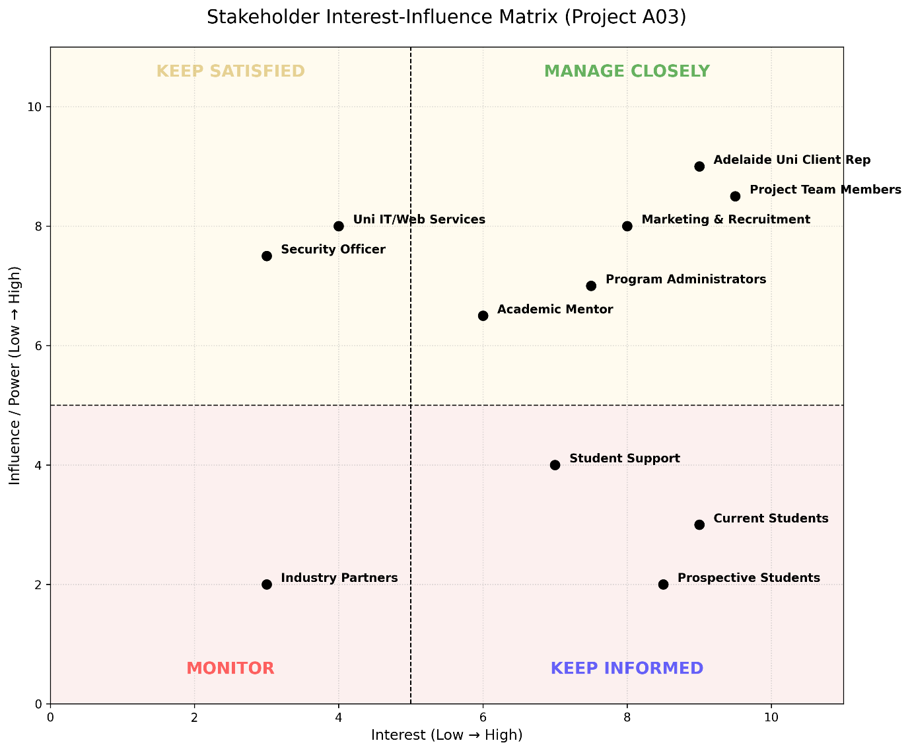 Note. This matrix organizes stakeholders based on the degree of interest/influence in order to guide stakeholder engagement strategy for different groups.

Deliverables and Project Evaluation Criteria

Deliverables
Final Report
Presentation
Source Files
Technical Documentation
User Requirement Analysis Report
Information Architecture Design
Prototype Website Demo
Implementation Roadmap

Evaluation Criteria
1. Accessibility
Proper contrast color system, typography size and spacing
Well defined page layout and content structure
2. Usability
Easy navigation
Interactive design
Users can easily find information
3. Content Quality
Content is accurate and up to date
Content is understandable, which meets user needs effectively
Contact information is credible and accessible
4. Information Structure
Clear and logical information architecture
Information is well-organized and easy to understand
5. Technical Performance
Pages and images load quickly
Additional resource links are accessible
6. Feasibility
Implementation roadmap is realistic and achievable
7. Completeness
All required deliverables are included and well-developed

Implementation Plan
This section introduces eight phases of the project and details each specific step that we will accomplish. The key milestones mark completion of each phase, making it accurate for members to track process.

Phase | Detailed Description of Activities | Key Milestone
Phase 1: Project Planning | - Conduct background research and clearly define the formal stakeholders.  - Define the boundaries of the project scope and determine priorities to arrange the completion sequence of each deliverable.  - Conduct a preliminary risk assessment and allocate financial budget resources.  - Develop a detailed project decomposition structure and project schedule, and present it using a Gantt chart. | Project Proposal completed
Phase 2: Requirement Analysis | 1. Conduct target user interviews and analyze functional/non-functional needs  2. Define core website objectives, system constraints, and functional logic  3. Translate user requirements into a formal Requirements Traceability Matrix | Requirements Analysis completed
Phase 3: Information Architecture | 1. Architect content hierarchy and structure digital assets for effective delivery  2. Design a comprehensive site map reflecting user journey pathways  3. Develop a strategic navigation system to optimize information discoverability | Information Architecture finalized
Phase 4: Wireframe and UI Design | 1. Construct low-fidelity wireframes followed by interactive high-fidelity prototypes  2. Define modular page layouts, UI components, and reusable design patterns  3. Establish a formal Style Guide including color palettes, typography, and grids | Wireframes and UI design defined
Phase 5: Development | 1. Execute front-end development using semantic HTML, CSS3, and JavaScript  2. Implement back-end logic and perform MySQL database schema normalization  3. Integrate front-end components with back-end APIs to ensure data flow | Website deliverable completed
Phase 6: Testing | 1. Compatibility: Perform cross-device (Desktop/Mobile) and cross-browser audits  2. Quality: Execute API validation, Selenium UI automation, and JMeter stress tests  3. UAT & Bug Fix: Conduct User Acceptance Testing and exhaustive regression tests | All testing and QA completed
Phase 7: Deployment | 1. Configure production server environment and execute secure database migration  2. Final production deployment followed by real-time live system monitoring  3. Conduct post-launch performance checks to ensure environmental stability | Website officially launched
Phase 8: Handover and Archiving | 1. Conduct the final project demonstration and deliver the formal presentation  2. Hand over all technical documentation, data models, and source file assets  3. Archive code on GitHub with a comprehensive README and operational manual | Final project delivered and archived

Project Schedule
The project schedule is developed by Gantt Chart within a timeframe from Week 1 to Week 10. This chart indicates project phases and related milestones during the project.
Figure 2
Project Timeline

Note. The horizontal green rectangles indicate tasks that compose each phase of the projects in 10 weeks while the horizontal blue diamonds represent milestone events for those projects.

Approval
We approve the project as described above.
Name | Role (e.g. student, client, mentor) | Signature | Date
Yilin Peng | Student | Yilin Peng | 20/03/2026
Jialao Liu | Student | Jialao Liu | 20/03/2026
Yuanxin Huang | student | Yuanxin Huang | 20/03/2026
Wenhao Liang | Mentor

